**Monkeypox disease on the way to spread around the world**

Authors : 1) Mr Rohit Patil 2) Ms Pratiksha Patil,

Email : [rohitsp7218@gmail.com](mailto:rohitsp7218@gmail.com), [pratikshabpatil355@gmail.com](mailto:pratikshabpatil355@gmail.com) Institute: Smt Sharadchandrika Suresh Patil collage of pharmacy chopda .

**Abstract**

The ongoing 2022 multicountry outbreak of monkeypox is the largest in history to occur outside of Africa. Monkeypox is an emerging zoonotic disease that for decades has been viewed as an infectious disease with significant epidemic potential because of the increasing occurrence of human outbreaks in recent years. As public health entities work to contain the current outbreak, healthcare professionals globally are aiming to become familiar with the various clinical presentations and management of this infection. We present in this review an updated overview of monkeypox for healthcare professionals in the context of the ongoing outbreaks around the world.

**Introduction**

Monkeypox is a virus transmitted to humans from animals with symptoms similar to those seen in the past in smallpox patients, although it is clinically less severe. With the eradication of smallpox in 1980 and subsequent cessation of smallpox vaccination, monkeypox has emerged as the most important orthopoxvirus for public health. Monkeypox virus is an enveloped double-stranded DNA virus that belongs to the Orthopoxvirus genus of the Poxviridae family.**1**

Earlier this month, the World Health Organization (WHO) declared the recent monkeypox outbreak a global health emergency. There are more than 16,000 reported cases of monkeypox within 75 countries and territories. Monkeypox has a current fatalityrate of between 3-6%. A recent study found 95% of monkeypox cases between April and June 2022 occurred during sex between men .Two vaccines are currently available to help protect against monkeypox . Human monkeypox was first identified in humans in 1970 in the Democratic Republic of the Congo in a 9-month-old boy in a region where smallpox had been eliminated in 1968. Since then, most cases have been reported from rural, rainforest regions of the Congo Basin, particularly in the Democratic Republic of the Congo and human cases have increasingly been reported from across central and west Africa. **2**

Globally, more than 16,000 monkeypox cases have been detected prompting the World Health Organization (WHO) to declare the Monkeypox outbreak as a global health emergency.Monkeypox is a viral zoonotic disease with symptoms similar to smallpox, although with less clinical severity.**3**

Since it was [first identified](https://journals.asm.org/doi/10.1128/br.37.1.1-18.1973) in a colony of monkeys in Copenhagen in 1958, [monkeypox](https://www.cdc.gov/poxvirus/monkeypox/faq.html" \t "_blank) has been [largely overlooked](https://www.science.org/content/article/monkeypox-is-a-new-global-threat-african-scientists-know-what-the-world-is-up-against) by the Western world. An infectious poxvirus that causes fever, chills and [rashes](https://www.cdc.gov/poxvirus/monkeypox/symptoms.html), the disease is [endemic](https://www.nature.com/articles/d41586-022-00155-x), or consistently regionally [present](https://www.cdc.gov/csels/dsepd/ss1978/lesson1/section11.html), in ten [African countries](https://www.who.int/emergencies/disease-outbreak-news/item/2022-DON385). Until [recently](https://abcnews.go.com/Health/wireStory/explainer-monkeypox-spreading-84832263), however, it was [rarely found](https://www.who.int/emergencies/disease-outbreak-news/item/2022-DON392) in Europe and the Americas—a trend that has, historically, led Western public health officials to [disregard](https://www.statnews.com/2022/06/05/monkeypox-recapitulating-stigma-structural-inequity-of-hiv-ebola-other-diseases/) its spread elsewhere.4

**Etiology**

**Subfamily:** chordopoxvirinae

**Genus:** orthopoxviru

**Species:** Monkeypox virus

On electron microscopy, the monkeypox virus is relatively large (200-250 nanometers). Poxviruses are brick-shaped, surrounded by a lipoprotein envelope with a linear double-stranded DNA genome.**5** Aside from their reliance on host ribosomes for mRNA translation, poxviruses include all necessary replication, transcription, assembly, and egress proteins in their genome.**6**

Monkeypox is usually a self-limited disease with the symptoms lasting from 2 to 4 weeks. Severe cases can occur. In recent times, the case fatality ratio has been around 3–6%.**7**

Monkeypox virus is an enveloped double-stranded DNA virus that belongs to the Orthopoxvirusgenus of the Poxviridae family. There are two distinct genetic clades of the monkeypox virus: the central African (Congo Basin) clade and the west African clade. The Congo Basin clade has historically caused more severe disease and was thought to be more transmissible.**7**

**Epidemiology**

Monkeypox (MPX) is a zoonotic disease and is currently the most prevalent orthopoxvirus infection in humans after the eradication of smallpox and the cessation of universal smallpox vaccination.8 Monkeypox has presumably occurred in sub-Saharan Africa for thousands of years, ever since humans acquired the virus through direct contact with infected animals.**9** Monkeypox was not recognized as a distinct disease until 1970 when the eradication of smallpox revealed the continued occurrence of smallpox-like illness in rural areas.**(9,10)**  In 1958, the monkeypox virus was first identified in laboratory monkeys at State Serum Institutes in Copenhagen, Denmark, and Africa for research purposes **(10,11)** Monkeypox has become a disease of global public health importance after 2003 due to the first outbreak in the USA linked to infected pet prairie dogs.**12**  Native prairie dogs housed with rodents imported from Ghana in Western Africa were thought to be the primary source of the outbreak as most of the infected individuals became sick after contact with pet prairie dogs. **(9,13)** In the summer of 2003, monkeypox had been identified to be the cause of a cluster of cases in the US Midwest. **9**  Since 2003, several cases of monkeypox have been reported in various countries with the largest outbreak experienced in Nigeria in 2017. **(10,12)**

In an epidemiological modeling study, the authors reported the R0 value of monkeypox to be between 1.10 and 2.40 in countries where exposure to Orthopoxvirus species is negligible, R0 is referred to as the reproductive ratio, or in other words, the degree of transmissibility of the disease. **14** This value suggests that an epidemic of monkeypox is imminent in scenarios of imported human or animal cases **(15,16)** The reported R0, as mentioned previously, suggests that each infected individual possesses the ability to infect one to two other people. Due to the transmissibility of the virus, it becomes imperative that an infected individual takes special measures to social distance and quarantine him/herself.

The Center for Disease Control and Prevention (CDC)  cases of monkeypox, distributed in 52 different countries around the globe **17** a visual depiction of the regional distribution of the cases globally. Many of the cases of monkeypox, currently, are concentrated within regions of Europe and within the western hemisphere.**12** Within Europe, current reports show that the largest number of cases are present in the United Kingdom. Currently, many of the confirmed cases of monkeypox are prevalent amongst individuals under the age of 40 years with a median age of 31 years. **11** This is a population born only after the discontinuation of the smallpox vaccination campaign, therefore further reflecting the lack of cross-protective immunity **(11,15)** There is also a higher prevalence of monkeypox cases among males, however, the exact explanation for this is unknown. Transmission of human monkeypox. In endemic countries, spillover events occur from zoonotic animal reservoirs into humans, potentially leading to limited outbreaks usually facilitated by close human contact. Outbreaks can also occur in nonendemic regions through introduction of the virus via human travel or importation of animals harboring the virus. Subsequent human-to-human transmission can then occur via household contacts and via other close contacts.

**Cases of monkeypox in world (45**) (Table No 1)

|  |  |  |  |
| --- | --- | --- | --- |
| **COUNTRY** | **CONFIRMED CASE** | **COUNTRY** | **CONFIRMED CASE** |
| **Benin** | **3** | **Uk** | **793** |
| **Cameroom** | **3** | **Israel** | **13** |
| **Congo** | **2** | **Singapur** | **1** |
| **Nigeria** | **41** | **Denmark** | **13** |
| **Brazil** | **11** | **Farnce** | **277** |
| **Germany** | **511** | **Hungry** | **7** |
| **Italy** | **85** | **Mexico** | **11** |
| **The Netherlands** | **167** | **America** | **142** |
| **Portugal** | **317** | **Lebanon** | **1** |
| **Slovenia** | **8** | **Ireland** | **24** |
| **Spain** | **520** | **Blegium** | **77** |
| **Sweden** | **13** | **Chile** | **3** |
| **Total** |  |  | **3,043** |

**Fig 1. Monkeypox detection in zone wise 45**

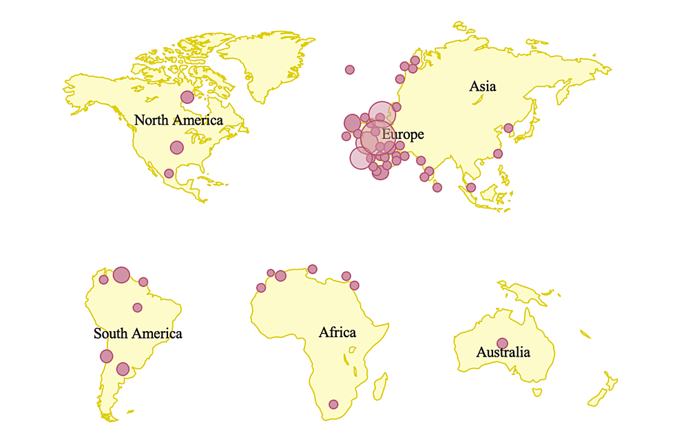

**Taxonomy of monkeypox virus**

**Taxonomy** 1  Table No 2

|  |  |
| --- | --- |
| **Microorganism** | **Virus** |
| Realm | Varidnaviria |
| Kingdom | Bamfordvirae |
| Phylum | Nucleocytoviricota |
| Class | Pokkesviricetes |
| Order | Chitovirales |
| Family | Poxviridae |
| Genus | Orthopoxvirus |
| Species | Monkeypox virus |

**Classification of poxvirus**

Monkeypox is one of the many zoonotic viruses that belong to the Orthopoxvirus genus of the Poxviridae family, as presented in Figure 3 Isolated from various animals the Poxviridae viruses are large, enveloped, double-stranded DNA viruses.**18** The major hosts of Poxviruses are rodents, rabbits, and non-human primates, which can occasionally be transmitted to humans facilitating the occurrence of human-to-human transmission. **19**

**Poxvirus classification 45** Table No 3

**Clinical presentation**

In the context of exposure and in the sylvatic setting persons are at increased risk for developing monkeypox if they live in forested areas and are male gender, are less than 15 years of age, and are not immune to smallpox **20**

Clinical presentation resembles smallpox but is less severe. Symptoms can vary depending on different factors, including exposure characteristics, age, presence of conditions that alter immune response, previous immunity for smallpox and viral strain. **21** Historically, patients have typically presented with prodromal symptoms, including fever, headaches, chills, malaise, and lymphadenopathy, followed by development of a characteristic rash . The rash usually starts in the mouth, and then spreads to the face and extremities, including the palms and soles. Each lesion begins as a macule and then progresses to papules, vesicles, pustules, and scabs . Pain can be prominent, but it is not universally present, and pruritus can occur when the lesions are in the healing stage. Unlike chickenpox, skin lesions due to monkeypox tend to be similar in size and typically present at the same stage. The number of lesions can range from 10 to 150 and can persist for up to 4 weeks **20**

**Monkeypox infection has two clinical phases**

A prodromal illness that lasts between 1 to 5 days characterized by fever, intense headache, lymphadenophathy, back pain, myalgia, fatigue. Other symptoms have been also described, such as sore throat, cough and less frequently, vomiting or diarrhea. In some cases, no prodromal symptoms were reported or these symptoms occurred after the beginning of the rash. A skin rash that begins 1-5 days after fever. The rash evolves from macules, papules, vesicles then pustules, before crusting, which then scale off. Lesions are frequently painful and can be pruritic. Lesions of different clinical stages can be present at the same moment. The number of lesions and affected regions can vary, Lesion can be found on all parts of the body, including palmar and plantar areas. In the current outbreak, lesions frequently begin and affect the genital, anal and oral areas. Some cases developed proctitis (for ex. rectal pain, bloody stools, diarrhea). Facial lesions can potentially lead to ocular involvement, affecting the conjunctivae and cornea.

**Symptoms last 2 to 4 weeks**

Children, pregnant women and some immunocompromised individuals are considered at higher risk for severe disease. Recent cases in Canada and western countries have been described as mild. Since May 2022, no deaths have been reported in western countries. Long-term skin effects, such as prolonged ulcer healing and scarring, have been described in the literature. Complications can include secondary infections (for example, cellulitis), and less frequently pneumonia, sepsis, encephalitis and keratitis leading to vision loss.**21**

**Trasmission**

Monkeypox virus is believed to have several modes of transmission, all of which are associated with direct contact with infected animals or the with infected humans. Human infections have been linked to contact with animals, but the precise exposure of a human case can be difficult to pinpoint in areas where contact with animals via household rodent infestations and the hunting or preparation of bushmeat from a variety of species is common **(22)** The exact mode of transmission of monkeypox is Suspected Modes of Transmission of Monkeypox till under investigation, however, the suspected modes of the transmission are those that were listed as risk factors for monkeypox contraction by Bunge et al. **(23)** . Animal to human transmission is direct contact or exposure with infected animals and most commonly, due to bodilmy fluids such as saliva, respiratory excretions, or could be the exudate from cutaneous or mucosal lesions. Viral shedding via feces may represent another exposure source **(24)**. Exposure to feces of infected animals can be an important risk factor in endemic regions of Africa where resources and infrastructure are scarce, causing individuals to sleep outside, on the ground, or live near or visit the forest where infected animals are much more prevalent. **(23)** In areas of scarce resources, such as food, households are left with no choice but to hunt and cook small mammals, increasing their risk of exposure to monkeypox. Although humanto-human transmission is less common than animal-to-human, it usually involves respiratory droplets with prolonged face-to-face contact or contact with lesions of an infected individual. **(25)**

**Fig 2. Transmission of monkeypox 47**

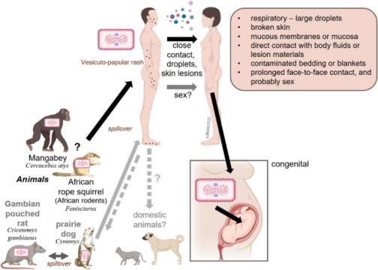

Contaminated objects/surfaces, such as sleeping on the same bedding, living in the same household, or eating or drinking from the same dishes as an infected individual, are deemed a risk factor for viral transmission among individuals of the same household. Amid the Current, ongoing monkeypox epidemic, it has also been observed that the disease is more common in males who have sex with female **(26)** According to the World Health Organization (WHO), it is not yet known whether monkeypox is sexually transmitted or not, however, the transmission can be attributed to close contact **(26,27)**. The pathogenesis and pathophysiology of monkeypox begin from the transmission of the virus, whether it be human-to-human transmission or animal-to-human transmission.

The most common cause of human-to-human transmission, as rare as it is considered, is respiratory droplets. lists direct contact with contaminated objects/surfaces and direct contact with mucocutaneous lesions of an infected individual. Monkeypox virus follows a similar infectious pathway to smallpox, beginning with the exposure of the oropharyngeal or respiratory mucosa of the host. Following the viral entry, the monkeypox virus replicates at the site of inoculation; in human-to-human transmission, the site of inoculation is the respiratory and oropharyngeal mucosa. Following viral replication, in primary viremia, the viral load spreads to the local lymph nodes. In secondary viremia, the viral load will reach the distant lymph nodes and organs through circulation. The entire process represents the incubation period, typically lasting seven to 14 days with an upper limit of 21 days **(28)**. Clinical manifestation of monkeypox is not visible during the incubation stage and, therefore, the incubation period is not contagious. The symptoms and clinical manifestation of monkeypox can be correlated to the prodromal stage. during the prodromal stage, secondary viremia occurs from the lymphoid organs to the skin and tertiary organs such as the lungs, eyes, gastrointestinal tract, etc. It is during the prodromal state that an individual is deemed to be the most infectious. This is largely due to the presence of symptoms such as mucocutaneous lesions, and lymphadenopathy, among other nonspecific symptoms

**Signs and Symptoms**

**Common (Nonspecific) Symptoms**

Fever

Headache

Myalgia

Backache

Lymphadenopathy

Chills

Exhastion

Rashes

Mouth and throat ulcer

**Complications**

Bacterial Superinfection

Comeal infection / Perment scarring

Bronchopneumonia

Spesis and Septic Shock

Cellulitis

Respiratory Distress

Emcephalitis

Dehydration **18**

Monkeypox symptoms usually start within 3 weeks of exposure to the virus. If someone has flu-like symptoms, they will usually develop a rash 1-4 days later.

Monkeypox can be spread from the time symptoms start until the rash has healed, all scabs have fallen off, and a fresh layer of skin has formed. The illness typically lasts 2-4 weeks**.29)**

**Diagnosis**

It is important to have a high index of suspicion for monkeypox infection and to be aware of the sometimes atypical presentations of the infection that have been described in the ongoing 2022 outbreak. When there is clinical suspicion for monkeypox, clinicians should ask about travel and sexual history and about any close contacts with people with a similar rash or suspected or confirmed monkeypox infection. Behaviors associated with close contact include sleeping in the same room, drinking or eating from the same container, living in the same residence, etc. **(30)**

More importantly, absence of travel history or absence of a specific known close contact with a rash or with suspected or confirmed monkeypox infection should not exclude the possibility of this diagnosis. A thorough skin examination should also be performed. The optimal diagnostic procedure for a patient with suspected active monkeypox infection is to obtain a specimen from a skin lesion to send for molecular testing by PCR. Ideally, more than 1 specimen should be obtained from 2 separate lesions on different parts of the body, and lesions should be unroofed to adequately sample virus containing secretions. Certain laboratories can perform direct PCR testing for MPXV specifically, whereas others perform generic OPXV testing that requires confirmatory testing for MPXV at a reference laboratory. However, in the context of the current outbreak, a positive OPXV test can reasonably be concluded to represent a diagnosis of monkeypox infection before results from confirmatory testing are available. Testing plans should ideally be coordinated with public health authorities in advance of specimen collection. Cell culture provides virus strains for further characterization, but it is restricted to accredited biosafety level 3 reference laboratories. **(31)**

Serological testing can potentially be helpful in epidemiologic investigations, retrospective diagnosis of past infections, and diagnosis of late clinical manifestations, such as encephalitis. MPXV serology can cross-react with prior smallpox vaccination, but this is not a concern in unvaccinated individuals. **(32)**

Sampling for diagnostic testing Monkeypox is diagnosed by PCR test on a viral swab taken from one or more vesicles or ulcers. Swabs should be sent in viral transport media. **(33)**

**Monkeypox Antigen Rapid Test Procedure**

1) Twist off the cap of the buffer bottle, carefully dispense all buffer into the extraction tube。

2) After collecting sample from skin leisions with thin swab, insert the swab into the extraction tube, plunge the swab up and down in the fluid for a minimum of 10 seconds. Hold the swab against the bottom of the tube, rotate three turns. DO NOT splash liquid out of the tube.

3) Remove the swab while squeezing the sides of the tube to extract the liquid from the swab.

4) Press the nozzle cap firmly onto the extraction tube. Mix thoroughly by swirling or flicking the bottom of the tube.

5)Gently squeeze the tube’s rigid body, dispense two (2) drops of the buffer-specimen mixture into the sample well on the monkeypox antigen test cassette.

5)Read the test results between 15 and 20 minutes. Do not read the results after 20 minutes.

**Fig 3. Rapid test 34**

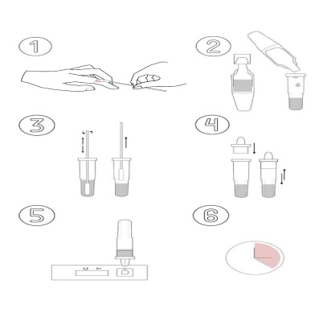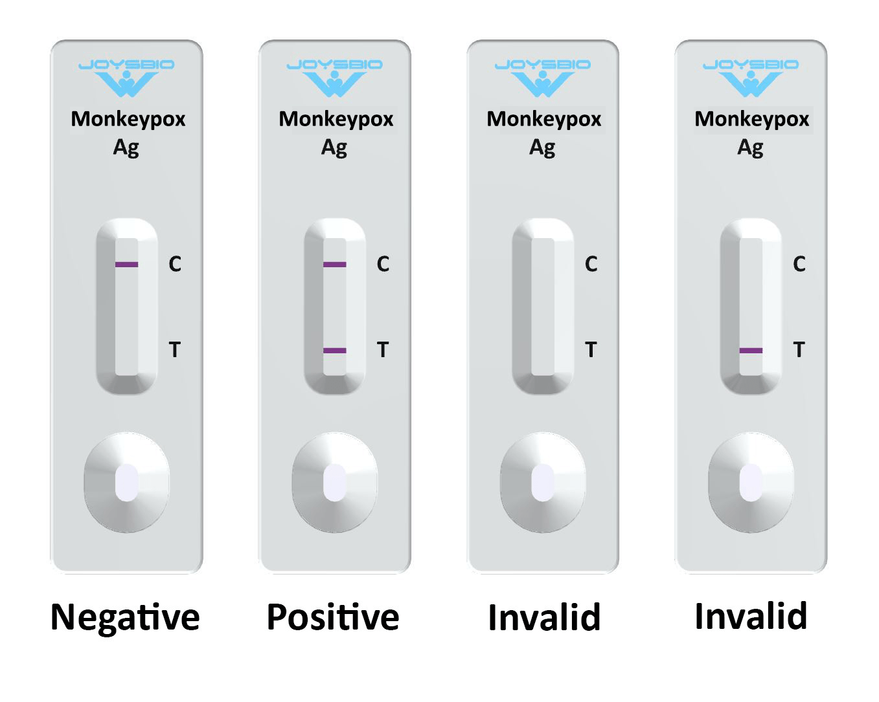

**Monkeypox Antigen Negative**

A coloured band appears on the control line (C line); no coloured band shows up on the test line (T line). A negative result indicates there is no monkeypox antigen in the specimen, or the level of monkeypox antigen is below the detection limit. Monkeypox Antigen Positive: A coloured band appears on the control line (C line), a second coloured band shows up on the test line (T line). A positive result indicates the presence of monkeypox virus antigen in the patient sample. Invalid Result: No coloured band appears on the control line (C line). An invalid test result suggests there might be insufficient buffer volume or incorrect operating procedures. Carefully review the test procedure and test the same patient again with another monkeypox antigen rapid test cassette. Contact your distributor if the problem persists. **(34)**

**Treatment**

Currently, there are no specific clinically proven treatments for monkeypox infection. As with most viral illnesses, the treatment is supportive symptom management. There are, however, prevention measures that can help prevent an outbreak.

The infected individual should remain in isolation, wear a surgical mask, and keep lesions covered as much as reasonably possible until all lesion crusts have naturally fallen off and a new skin layer has formed. For severe cases, investigational use can be considered for compounds with demonstrated benefit against orthopoxviruses in animal studies and severe vaccinia vaccine complications. The oral DNA polymerase inhibitor brincidofovir, oral intracellular viral release inhibitor tecovirimat, and intravenous vaccinia immune globulin have unknown efficacy against the monkeypox virus**(35)**

For individuals exposed to the virus, temperature and symptoms should be monitored twice per day for 21 days because that is the accepted upper limit of the monkeypox incubation period. Infectiousness aligns with symptom onset; therefore, close contacts need not isolate while asymptomatic. In some cases, post-exposure vaccination with modified vaccinia, Ankara vaccine (smallpox and monkeypox vaccine, live, non-replicating) is recommended. Contact between broken skin or mucous membranes and an infected patient’s body fluids, respiratory droplets, or scabs is considered a “high risk” exposure that warrants post-exposure vaccination as soon as possible. According to the CDC, vaccination within four days of exposure may prevent disease onset, and vaccination within 14 days may reduce disease severity.

The replication-defective modified vaccinia Ankara vaccine is a two-shot series, four weeks apart, with a superior safety profile compared to first and second-generation smallpox vaccines. Unlike live vaccinia virus preparations, administering modified vaccinia, Ankara does not create a skin lesion or pose a risk of local or disseminated spread. **(35)** In addition, clinical trials have shown that modified vaccinia Ankara is safe and stimulates antibody production in patients with atopy and compromised immune systems, which are known contraindications to live vaccinia administration. **(36)**

Identifying the potential benefits and drawbacks of preventative monkeypox vaccination in endemic communities requires more thorough data collection and feasibility analysis. Access to medical care, testing capabilities, and infrastructure limits the ability to make informed decisions about best addressing this neglected tropical disease**(36)(37)(38)**

Currently, there are 3 antiviral compounds that are being assessed to treat monkeypox:ST-246 prevents the release of the virus from the cell and is shown to be effective in controlling the infection of several Orthopox viruses. It has not been licensed to treat monkeypox infections but is partially used to treat other Orthopox virus infections.

Cidofovir disrupts viral multiplication by inhibiting an enzyme involved in virus multiplication. However, the drug is toxic to the kidneys. It is provisionally allowed to treat other Orthopox virus infections.CMX-001 is a modified cidofovir compound that is not toxic to the kidneys. It has been shown to be effective in controlling the replication of different Orthopox viruses. It is still under development.

Vaccinia virus vaccines, which were used for small pox, are also used as vaccination tools. However, the live virus is a cause for concern since complications may arise in some individuals with a compromised immune system. Inactivated vaccinia viruses are also used but are not as effective as some of the compounds mentioned above. It is recommended by the Center for Diseases and Control (CDC) in the United States to vaccinate a person in advance if it is known that they will be operating in a monkeypox-infection sensitive area. Following contact with an infected individual, it is recommended the vaccination be given within 4 to 14 days of exposure. **(39)**

**Potential Treatment Options for Monkeypox Infection (44) Table No 4**

|  |  |  |  |  |  |
| --- | --- | --- | --- | --- | --- |
| **Therapy** | **Mechanism of Action** | **Typical Dosing** | **Formulation** | **FDA Approval Status** | **Side Effects and Adverse Events** |
| Cidofovir | Blocks viral DNA synthesis through competitive inhibition of DNA polymerase | 5 mg/kg per dose once weekly for ≥2 doses (with concomitant probenecid) | IV; off-label: topical, intravesicular | CMV retinitis in patients with AIDS [1] (1996) | Nephrotoxicity; neutropenia; decreased intraocular pressure, nausea, vomiting |
| Brincidofovir | Lipid conjugate prodrug of cidofovir | 4 mg/kg once weekly for 2 doses (max 200 mg/dose | Oral | Smallpox (2021) [2) | Abdominal pain, nausea, vomiting, diarrhea, elevated liver transaminases and bilirubin |
| Tecovirimat | Inhibits activity of the protein VP37, which prevents creation of virions that can be released from an infected host cell, thereby preventing replication and dissemination within the host | IV: 35 to <120 kg: 200 mg q12 hours  ≥120 kg: 300 mg q12 hours  Oral: 40 to <120 kg: 600 mg q12 hours  ≥120 kg: 600 mg q8 hours  All regimens for 14 days | IV and oral (off-label topical) [84] | Smallpox (2018) (3] | IV: pain and swelling at infusion site; extravasation at infusion site; headache [86]  Oral: headache, abdominal pain, nausea, vomiting |
| VIGIV | Passive immunity through OPXV-specific antibodies collected from pooled human plasma of persons immunized with smallpox vaccine | 6000 units/kg as a single dose (up to 9000 units/kg) Dose can be repeated depending upon symptoms | Iv | Complications of vaccinia vaccination (progressive vaccinia, severe generalized vaccinia, etc) (2005) [4] | Infusion reaction; local injection-site reaction (contraindicated in persons with IgA deficiency and possible IgA hypersensitivity) |

Abbreviations: AIDS, acquired immunodeficiency syndrome; CMV, cytomegalovirus; DNA, deoxyribonucleic acid; FDA, US Food and Drug Administration; IgA, immunoglobulin A; IV, intravenous; Max, maximum; VIGIV, vaccinia immunoglobulin intravenous.

**Patient Education:**

**1)** Avoid close, skin-to-skin contact with people who have a rash thatAvoid contact with objects and materials that a person with monkeypox has used. **(40)**

**2 )Avoid contact with objects and materials that a person with monkeypox has used.**

Do not share eating utensils or cups with a person with monkeypox.

Do not handle or touch the bedding, towels, or clothing of a person with monkeypox. **(40)**

**3)Wash your hands often.**

Wash your hands often with soap and water or use an alcohol-based hand sanitizer, especially before eating or touching your face and after you use the bathroom. **(40)**

4)Avoid contact with infected animals (especially sick or dead animals).

Avoid contact with bedding and other materials contaminated by the person infected with the virus. **(41)**

Monkeypox symptoms, especially among individuals with relevant travel history.

Transmission and incubation

Specimen collection.

Infection control procedures in the home and hospital

Clinical recognition, and the characteristic rash associated with monkeypox.

Prophylaxis and possible treatments for monkeypox.

Monitoring of those exposed to monkeypox. **(42)**

4) According to the World Health Organization (WHO), public health messages, proper hygiene, appropriate caution should be exercised based on the situation. Public health messages should convey the information that one must wear protective gloves and other equipment when they come in contact with an infected animal or human. Individuals should always wash their hands thoroughly after touching infected animals or individuals. People should make sure that the meat is cooked thoroughly to avoid any contamination or infection. **(43)**

**Conclusion**

Monkeypox is not yet widespread but its warning signs are alarming. Since there is no vaccine against this disease till date, we have to understand its seriousness.

Monkeypox is a viral zoonosis (a virus transmitted to humans from animals) with symptoms similar to those seen in the past in smallpox patients, although it is clinically less severe. With the eradication of smallpox in 1980 and subsequent cessation of smallpox vaccination, monkeypox has emerged as the most important orthopoxvirus for public health. Monkeypox primarily occurs in central and west Africa, often in proximity to tropical rainforests, and has been increasingly appearing in urban areas. Animal hosts include a range of rodents and non-human primates.

The features of this disease, its consequences, and how dangerous it is to human life, as well as its virus and its species, are given in depth. Scientists have also predicted that this disease will be cured soon by newly define vaccine.

**Reference**

1)World health organization introduction of monkeypox Available at<https://www.who.int/news-room/fact-sheets/detail/monkeypox>

2)Medical News Today. Monkeypox : Why it is now a health emergency ,and how to avoid infection Available at <https://www.medicalnewstoday.com/articles/monkeypox-why-it-is-now-a-health-emergency-and-how-to-avoid-infection#What-is-monkeypox>?

3) Mint e-paper Available at <https://www.livemint.com/news/india/delhi-reports-1st-case-of-monkeypox-total-4-cases-now-in-india-11658648513514.htm>

4) Smithsonian magazine . What you need to know about the history of monkeypox Available at <https://www.smithsonianmag.com/history/what-you-need-to-know-about-the-history-of-monkeypox-180980301/>

5) Alakunle E, Moens U, Nchinda G, Okeke MI. Monkeypox Virus in Nigeria: Infection Biology, Epidemiology, and Evolution. Viruses. 2020 Nov 05;12(11)

6) Walsh D. Poxviruses: Slipping and sliding through transcription and translation. PLoS Pathog. 2017 Nov;13(11):e1006634.

7) World health organization . Available at [https://www.who.int/news-room/fact sheets/](https://www.who.int/news-room/fact%20sheets/)

8)European Central for Disease Prevention and Control Available at <https://www.ecdc.europa.eu/en/news-events/epidemiological-update-monkeypox-multi-country-outbreak>

9) Nalca A, Rimoin AW, Bavari S, Whitehouse CA: Reemergence of monkeypox: prevalence, diagnostics, and countermeasures. Clin Infect Dis. 2005, 41:1765-71. 10.1086/498155

10) Appendix 2. Monkeypox virus. (2009). Accessed: June 20, 2022:<https://www.aabb.org/docs/default-source/default-document-library/regulatory/eid/130s.pdf>

11) Petersen E, Kantele A, Koopmans M, Asogun D, Yinka-Ogunleye A, Ihekweazu C, Zumla A: Human monkeypox: epidemiologic and clinical characteristics, diagnosis, and prevention. Infect Dis Clin North Am. 2019,

12) [Monkeypox](https://www.who.int/news-room/fact-sheets/detail/monkeypox?utm_medium=email&utm_source=transaction). (2022). Accessed: June 22, 2022: [https://www.who.int/news-room/fact-sheets/detail/monkeypox](https://www.who.int/news-room/fact-sheets/detail/monkeypox?utm_medium=email&utm_source=transaction).

13) Sejvar JJ, Chowdary Y, Schomogyi M, et al.: Human monkeypox infection: a family cluster in the midwestern United States. J Infect Dis. 2004,

14) Hussain A, Kaler J, Tabrez E, Tabrez S, Tabrez SS: Novel COVID-19: a comprehensive review of transmission, manifestation, and pathogenesis. Cureus. 2020,

15) Okyay RA, Bayrak E, Kaya E, et al.: Another epidemic in the shadow of Covid 19 pandemic: a review of monkeypox. EJMO. 2022, 6:95-9. 10.14744/ejmo.2022.2022

16)Grant R, Nguyen LL, Breban R: Modelling human-to-human transmission of monkeypox. Bull World Health Organ. 2020

17)Central for disease Control and prevention 2022 global map & case count. (2022). Accessed: July 1, 2022: Available at [https://www.cdc.gov/poxvirus/monkeypox/response/2022/world-map.htmldetail/monkeypox#:~:text=Monkeypox%20is%20caused%20by%20monkeypox,been%20around%203%E2%80%936%25.**(WOH)**](https://www.cdc.gov/poxvirus/monkeypox/response/2022/world-map.htmldetail/monkeypox#:~:text=Monkeypox%20is%20caused%20by%20monkeypox,been%20around%203%E2%80%936%25.(WOH))

18) Microbiologyand molecular biology Reviews Available at Joklik WK: [The poxviruses](https://dx.doi.org/10.1128/br.30.1.33-66.1966?utm_medium=email&utm_source=transaction). Bacteriol Rev. 1966, 30:33-66. [10.1128/br.30.1.33-66.1966](https://dx.doi.org/10.1128/br.30.1.33-66.1966?utm_medium=email&utm_source=transaction)

19) Sciencedirect monkeypox Available at Haller SL, Peng C, McFadden G, Rothenburg S: [Poxviruses and the evolution of host range and virulence](https://dx.doi.org/10.1016/j.meegid.2013.10.014?utm_medium=email&utm_source=transaction). Infect Genet Evol. 2014, 21:15-40. [10.1016/j.meegid.2013](https://dx.doi.org/10.1016/j.meegid.2013.10.014?utm_medium=email&utm_source=transaction)

(20) Oxford Academic .Monkeypox : A contemporary Review for Healthcare Professionals Available at [**https://academic.oup.com/ofid/article/9/7/ofac310/6615388**](https://academic.oup.com/ofid/article/9/7/ofac310/6615388)

21) BC Center of Disease Control. Monkeypox Available at [**http://www.bccdc.ca/health-professionals/clinical-resources/monkeypox#clinical**](http://www.bccdc.ca/health-professionals/clinical-resources/monkeypox#clinical)

(22) McCollum AM, Damon IK: Human monkeypox. Clin Infect Dis. 2014, 58:260-7. 10.1093/cid/cit703

(23) Bunge EM, Hoet B, Chen L, Lienert F, Weidenthaler H, Baer LR, Steffen R: The changing epidemiology of human monkeypox—a potential threat? A systematic review. PLoS Negl Trop Dis. 2022, 16:e0010141.

(24) Hutson CL, Olson VA, Carroll DS, et al.: A prairie dog animal model of systemic orthopoxvirus disease using West African and Congo Basin strains of monkeypox virus. J Gen Virol. 2009, 90:323-33. 10.1099/vir.0.005108-0

(25) Simpson K, Heymann D, Brown CS, et al.: Human monkeypox - after 40 years, an unintended consequence of smallpox eradication. Vaccine. 2020, 38:5077-81. 10.1016/j.vaccine.2020.04.062

(26) Okyay RA, Bayrak E, Kaya E, et al.: Another epidemic in the shadow of Covid 19 pandemic: a review of monkeypox. EJMO. 2022, 6:95-9. 10.14744/ejmo.2022.2022

(27)World Health organization Available at Monkeypox. (2022). Accessed: June 22, 2022: <https://www.who.int/news-room/factsheets/detail/monkeypox>

(28) Moore M, Zahra F: Monkeypox. StatPearls [Internet], Treasure Island (FL); 2022..

29)Microbiologyand molecular biology Reviews Available at Joklik WK: [The poxviruses](https://dx.doi.org/10.1128/br.30.1.33-66.1966?utm_medium=email&utm_source=transaction). Bacteriol Rev. 1966, 30:33-66. [10.1128/br.30.1.33-66.1966](https://dx.doi.org/10.1128/br.30.1.33-66.1966?utm_medium=email&utm_source=transaction) #https://www.cdc.gov/poxvirus/monkeypox/symptoms.html

30) Bunge EM, Hoet B, Chen L, et al. The changing epidemiology of human monkeypox-a potential threat? A systematic review. PLoS Negl Trop Dis 2022; 16:e0010141. Doi:10.1371/journal.pntd.0010141

31)Centers of Disease Control and Prevention. Biosafety in Microbiological and Biomedical Laboratories. Editors PJ Meechan and J Potts). 6th ed. Available at: https://www.cdc.gov/labs/pdf/CDCBiosafetyMicrobiologicalBiomedicalLaboratories-2020-P.pdf. Accessed 17 June 2022.

32) Hammarlund E, Lewis MW, Carter SV, et al. Multiple diagnostic techniques identify previously vaccinated individuals with protective immunity against monkeypox. Nat Med 2005; 11:1005–11. doi:10.1038/nm127

33) Monkeypox: diagnostic testingFrom:UK Health Security Agency . Published24 May 2022.Last updated 1 August 2022

34) Joysbio Monkeypox Rapid Test Kit Available at <https://en.joysbio.com/monkeypox-rapid>

35) McCollum AM, Damon IK. Human monkeypox. Clin Infect Dis. 2014 Jan;58(2):260-7.

36) Petersen BW, Kabamba J, McCollum AM, Lushima RS, Wemakoy EO, Muyembe Tamfum JJ, Nguete B, Hughes CM, Monroe BP, Reynolds MG. Vaccinating against monkeypox in the Democratic Republic of the Congo. Antiviral Res. 2019 Feb;162:171-177. [PMC free article] [PubMed]

37) Sklenovská N, Van Ranst M. Emergence of Monkeypox as the Most Important Orthopoxvirus Infection in Humans. Front Public Health. 2018;6:241. [PMC free article] [PubMed]

38) Reynolds MG, McCollum AM, Nguete B, Shongo Lushima R, Petersen BW. Improving the Care and Treatment of Monkeypox Patients in Low-Resource Settings: Applying Evidence from Contemporary Biomedical and Smallpox Biodefense Research. Viruses. 2017 Dec 12;9(12) [PMC free article] [PubMed]

39)Medindia monkeypox Available at <https://www.medindia.net/amp/patients/patientinfo/monkeypox.htm>

(40)Central For Disease Control and prevention Available at <https://www.cdc.gov/poxvirus/monkeypox/prevention/protect-yourself.html>

(41)Medindia monkeypox Available at <https://www.google.com/amp/s/www.medindia.net/amp/news/healthinfocus/monkeypox-outbreak-what-it-is-how-does-it-spread-the-prevention-207280-1.htm>

(42)Florida Health orange country Available at <https://orange.floridahealth.gov/newsroom/2022/08/Nationwide-MonkeyPox-Outbreak.html>

(43)MD Medindia monkeypox Available at <https://www.medindia.net/patients/patientinfo/monkeypox.htm>

44) Oxford Academic monkeypox Available at <https://academic.oup.com/ofid/article/9/7/ofac310/6615388>

45) World health organization . Multi country monkeypox outbreak : situation update Available at <https://www.who.int/emergencies/disease-outbreak-news/item/2022-DON396>

46) Cureus . Monkeypox : A Comprehensive review of transmission Available at <https://www.cureus.com/articles/100707-monkeypox-a-comprehensive-review-of-transmission-pathogenesis-and-manifestation>

47)BMC Annals of Clinical Microbiology and Antimicrobials Available at <https://ann-clinmicrob.biomedcentral.com/articles/10.1186/s12941-022-00518-2>